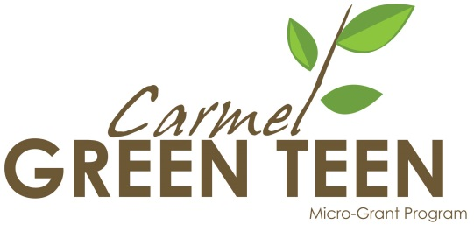
MICRO-GRANT APPLICATION FORM

IMPORTANT: Special permission is required for projects to take place at Carmel Clay Schools. The Administrative Approval Form for Carmel Clay Schools allows the upper administration to evaluate project feasibility within the schools. It is due February 18, 2015. The form and instructions are attached to this application. Note that other beneficiary organizations (schools, parks, churches) may have different approval processes and forms. It is the applicant’s responsibility to understand and meet these requirements.

1. Tell us about yourself and your group:
Project Title:
(Choose a unique name that describes your project.)
Dollar Amount Requested:
(Must be $1000 or less, and must equal the amount requested on the Budget page.)
Youth Project Leader: |  | Age:
Address:
City: |  | Zip:
Home/Cell: |  | E-Mail:

Adult Advisor: |  |  | Title:
Work/Cell Phone: |  |  | Home Phone:
Address:
City: |  |  | Zip:
E-Mail: |  |  | Fax:

- Tell us about your sponsoring organization:

Your project must have a SPONSORING ORGANIZATION (must match page 5) such as the Scouts, a religious organization, school or another organization which is able to show proof of nonprofit status. If your group is not incorporated as a nonprofit organization, the Carmel Green Teen Micro-Grant Program will help you locate a sponsor. Please contact us at least one week prior to the application due date for assistance.

Sponsoring Nonprofit:
(Name the organization, school, or agency that will ensure use of funds and youth safety.)
Contact Person:
Address:
City: |  | Zip:
Phone: |  | E-Mail:

3. Tell us about your environmental project:

Describe the environmental need you are addressing and how you identified that need.

Describe who will benefit from this project.

Describe your project and any related activities. Tell us what you will need to carry out this project and how the project will take place.

Describe how your project will help educate the community about caring for the environment.

Being “green” often means being frugal and resourceful as well. Please tell us how you have been frugal and resourceful in planning your project (reusing materials, asking volunteers to provide tools, finding discounts, requesting donations, etc).

(If needed, you may add additional pages to further describe your project.)

4. Describe how will you evaluate the outcomes of your project:
Outcomes are benefits or changes for individuals or populations that occur during or after participating in program activities. Outcomes may relate to benefits, behaviors, skills, knowledge, attitudes, values, conditions, or other attributes.

How will the project reduce pollution, conserve natural resources, or save energy in Carmel?

How will you measure the environmental impact of your project?

How will you measure the community impact of your project?

What does your group hope to learn while planning and implementing this project? How will you measure or track this?

Where will your project take place? (List location(s) where service project will take place.)

When will this project begin and end? (List days, dates, and times) Please be specific.

How many youth volunteers will actively participate in the project?

About how many people will be served by this project? Under 50 50-100 Over 100

Were any youth involved in the planning and/or writing of this grant application? YES NO
If so, who?

Do you have all necessary permission to do this project? YES NO

Does your project take place at a Carmel Clay School or property? YES NO

If your answer is yes:

Have you filled out and submitted the necessary Administrative Approval Form? YES NO

This form and the necessary instructions are available on the final page of this application form.
This brief form needs to be submitted by February 18, 2014. Please take the time to do this now.

Are there any special permission slips or insurance coverage needed? YES NO
If so, what kind, and who will be responsible for obtaining them?

Do you have permission for the youth and adult participants to be photographed while doing the project?
YES NO
The Carmel Green Teen Micro-Grant Program will post project photos (using project and group names only) on its website. These project web pages will serve to educate the public and motivate other young people in environmental stewardship.

Will any other organization or agency be involved with your project? YES NO
If yes, please list the organization, telephone number, contact person and title.

Name of organization: |  | Phone:
Name of contact person: |  | Title:

Please tell us how you learned about the Carmel Green Teen Micro-Grant Program.
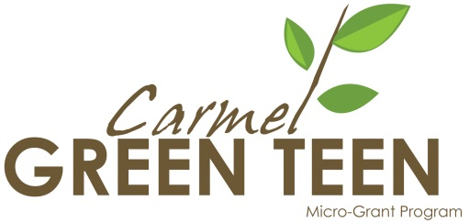
5. Signature Verification
This page must be printed and signed - signatures are required – see page 7.
The undersigned certify that:
- The sponsoring organization listed below assumes all responsibility for liability.
- All information contained is accurate and contains no misstatements or misrepresentations.
- The project proposal was initiated and prepared by youth.
- The project will be planned and carried out by youth.
- Photos of participants engaging in project will be provided and the promotional use of photos allowed.

Name and short description of your youth group:
(Examples: Boy Scout Troop #______; Key Club; 4-H; church youth group)
Youth Leader: |  |  | Adult Advisor:
Signature | Date |  | Signature | Date
Title | Phone |  | Title | Phone

Describe the main activities of the SPONSORING ORGANIZATION (must match sponsor on page 1). (Examples: school; church; nonprofit agency) You may include the organization’s Mission Statement. Use additional paper if necessary, or attach a brochure. This is the nonprofit organization to which the grant check is written and for which you have provided necessary documentation. The representative below must have the authority to receive and disseminate these funds

This certification must be signed by an officer of the organization with knowledge of the matters contained in the grant application form. This would ordinarily be the chief officer of the board, agency director, school principal or church pastor (not the adult project advisor listed above).
Sponsoring Organization Representative:
 | Printed Name
Signature/Title Non-Profit Tax ID# | Phone
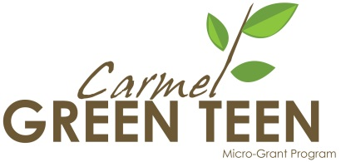

APPLICATION BUDGET

- Complete the following budget sheet, including a short description of your budget items. Attach additional sheets if necessary.

PROJECT NAME: |  | DATE:

Description of Item | Cost of Item | Amount Donated* | Amount Requested**
OPERATIONAL COSTS - (i.e. supplies, materials, equipment rental, etc.)
PROMOTIONAL COSTS - (i.e. t-shirts, flyers, other)
TRAVEL
TOTALS - add up each column
* Preference may be given to groups that secure at least 10% of total project costs through vendor discounts, in-kind donations, or monetary donations. What contributions can your group make or obtain to help contribute to or minimize the cost of your project?
** Amount that you are asking to have funded through the Carmel Green Teen Micro-Grant Program

Name of sponsoring organization representative (not necessarily the adult project advisor) who is in charge of receiving the award check and overseeing use of funds.

Name: |  | Title:
E-mail: |  | Phone:

(Please attach pictures, plans, or itemized quotes to support budget requests.)
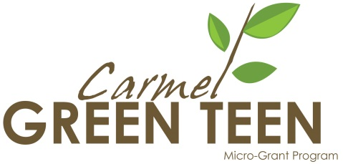

KEEP THIS PAGE FOR YOUR RECORDS!

In order to be considered for funding, we must receive ALL of the following:

- Completed application with Budget page – Please include item pictures or details.
- Approval by the Carmel Clay Schools Green Administrative Team – See page 9.
- Proof of sponsoring organization’s nonprofit status (except for public schools)
- Additional information about sponsoring organization or group (optional)
- Signature Verification (page 5) – A scanned copy may be emailed or the original form may be mailed or dropped off at the address below by the application due date. Original signed copy must be provided at the grant review session.
- Make and keep a copy of the grant application and budget for your group.

We encourage groups to reduce paper waste by downloading the Carmel Green Teen Micro-Grant Application as a Microsoft Word file, filling it in electronically, and saving it as a *.doc or *.pdf file. Please email the completed application file as an attachment to admin@CarmelGreenTeen.org. All supporting documents may be scanned and emailed as attachments as well.

Emailed Microsoft Word documents are strongly encouraged. However, applications may also be printed and mailed or dropped off. Please do not fill in using pencil.
If you plan to drop off your application at the address below, please contact us via email to let us know to expect it. You will then receive an email confirmation of receipt.

A MANDATORY REVIEW SESSION WILL BE HELD ON MARCH 8, 2015.
GRANT APPLICANTS (AT LEAST TWO YOUTHS AND ONE ADULT)
MUST BE IN ATTENDANCE TO BE CONSIDERED FOR FUNDING.

Mail any correspondence to:

Carmel Green Teen Micro-Grant Program
13810 Laredo Drive
Carmel, IN 46032

HAVE QUESTIONS?
Visit CarmelGreenTeen.org or email us at admin@CarmelGreenTeen.org

CCS Administrative Approval Form due February 18, 2015.
Applications must be received by February 28, 2015.

Here is an additional page to use if you did not have room to complete your answers,
or if you have extra information about yourself that you would like to share. Thank you.

Administrative Approval Form for Projects at Carmel Clay Schools

For students whose Carmel Green Teen project will take place at a Carmel Clay school or on school property, approval of the proposed project is needed from the Carmel Clay Schools Green Administrative Team. Please fill out this form and email the completed form to The Carmel Green Teen Micro-Grant Program and Kim Barrett, Principal of Smoky Row Elementary School by February 18, 2015 to guarantee your ability to meet the February 28, 2015 application due date. You may also copy and paste this page into the necessary email.

Student’s Name / Youth Leader of Project:

Student’s Email:

Student’s Club or group involved:

Student’s School:

School or School Property where project will take place:

Adult / Teacher Advisor Name and Title:

Adult / Teacher Advisor Email:

Name of Proposed Carmel Green Teen Project:

Briefly describe the proposed Carmel Green Teen service-learning project. Only 2-3 sentences are necessary. Please include proposed project dates.

Please email completed form to admin@carmelgreenteen.org and kbarrett@ccs.k12.in.us,
by February 18, 2015. You will receive an email response by February 21, 2015.
Forms received prior to this date will receive a response within 3-5 business days.
Only after the Carmel Clay Schools Green Administrative Team approves your project, may you then proceed to obtain final project approval from your principal or assistant principal with a signature on page 5 of the Carmel Green Teen Micro-Grant Application Form.
Please contact admin@carmelgreenteen.org with any questions.

