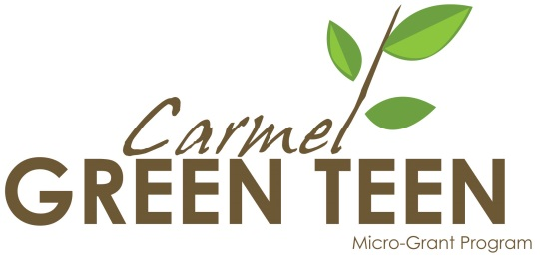

Administrative Approval Form for Projects at Carmel Clay Schools

For students whose Carmel Green Teen project will take place at a Carmel Clay school or on school property, approval of the proposed project is needed from the Carmel Clay Schools Green Administrative Team. Please fill out this form and email the completed form by February 23, 2018 to guarantee your ability to meet the March 16, 2018 application due date. You may also copy and paste this page into the necessary email.

Student’s Name / Youth Leader of Project:

Student’s Email:

Student’s Club or group involved:

Student’s School:

School or School Property where project will take place:

Adult / Teacher Advisor Name and Title:

Adult / Teacher Advisor Email:

Name of Proposed Carmel Green Teen Project:

Briefly describe the proposed Carmel Green Teen service-learning project. Only 2-3 sentences are necessary unless you need more space to describe the project fully. Please include proposed project dates.

Please email completed form to BOTH kdavis1@ccs.k12.in.us and laurieb@cicf.org by February 23, 2018.

Only after the Carmel Clay Schools Green Administrative Team approves your project, may you then proceed to obtain final project approval from your principal or assistant principal with a signature on page 5 of the Carmel Green Teen Micro-Grant Application Form.
Please contact laurieb@cicf.org with any questions.

